MARK YOUR CALENDARS

- August 3, 2017 – Open House/Curriculum Night (Track 4) – 5:30 pm – DRES
- August 4, 2017 – First Spirit Wear Day of the Year! – All Day - DRES
- August 8, 2017 - SPIRIT NIGHT at United Skates of America-Raleigh- 6:00pm
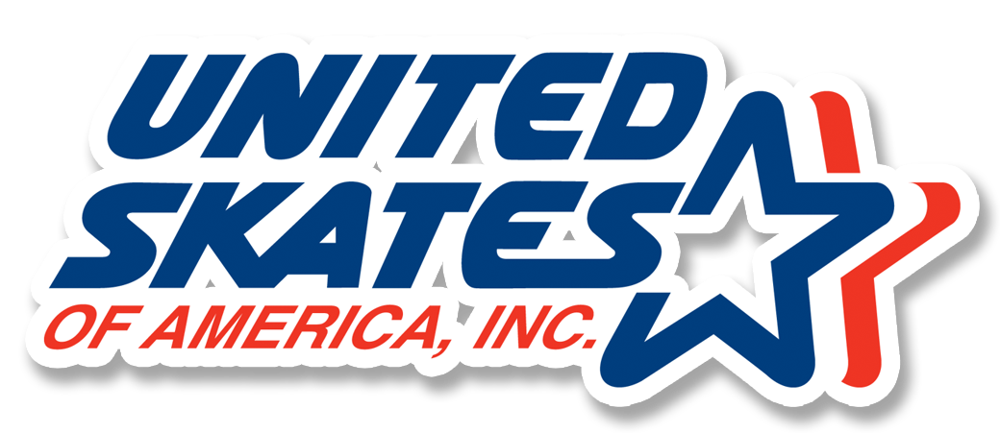
- August 8, 2017 – Fall Pictures (Tracks 1-2)
- August 18, 2017 – Teacher Appreciation Event
- August 21, 2017 – Read-a-Thon Assembly (Tracks 1, 3 and 4)
- August 28, 2017 – PTA Meeting, 6:30 pm, Media Center
- August 28, 2017 – September 22 – PTA Read-a-Thon
AUGUST 2017 DURANT DISPATCH
DURANT ROAD ELEMENTARY SCHOOL

PRINCIPAL’S MESSAGE

By Janet Kehoe
This year at DRES, we added STEM as a specials class. STEM (Science, Technology, Engineering, Mathematics) pervades every part of our lives. Science is everywhere in the world around us. Technology is continuously expanding into every aspect of our lives. Engineering is the basic designs of roads and bridges, but also tackles the challenges of changing global weather and environmentally-friendly changes to our home. Mathematics is in every occupation, every activity we do in our lives. By exposing students to STEM and giving them opportunities to explore STEM-related concepts, we believe they will develop a passion for it and possibly pursue a job in a STEM field. A curriculum that is STEM-based uses real-life situations to help students learn. STEM activities provide hands-on and minds-on lessons for each student. Making math and science both fun and interesting helps the student do much more than just learn.

When students attend our STEM special, they will frequently use MakerSpace. Students will engage in hands-on activities that are creative, collaborative, and require students to be critical thinkers and communicate effectively. We have hired Keri Behr as our STEM teacher, who was with us last year in another position but we are so excited to have her teaching STEM for the 2017-2018 school year.

PTA PRESIDENT’S MESSAGE

By Kyra Walgos
Tracks 1-3 are a few weeks in and Track 4 is rolling in. As a Track 4 parent, I couldn’t be more excited! With everyone back, the events at DRES will start coming fast and furious and our calendars will fill up before we know it.

I hope you take this opportunity to join the DRES PTA. The cost is $10 per person (parents, grandparents, friends and family can all join) and you can join through the MemberHub website or by completing the form sent home by your teachers.

What is the PTA and why is it important to you? National PTA offers a great explanation: “The PTA's mission is to make every child’s potential a reality by engaging and empowering families and communities to advocate for all children.” DRES is our children’s little lifeboat and the parents, staff, teachers, friends and family are all in that boat paddling together. It’s about investing in the DRES community to help everyone in it meet their individual potential. I look forward to meeting each of our new members this year!

FALL FUNDRAISER – Read-A-Thon
Your DRES PTA is pleased to announce that our fall fundraiser will be a Read-a-thon. The program runs August 28th - September 8th for Tracks 1 and 4 and September 11th - September 22nd for Tracks 2 and 3. Students will do their program reading at school and earn prizes based on their collected donations. All donations will be flat amounts.
This fall fundraiser change was made to address parent and administrator feedback; to significantly reduce program administrative fees; and to establish a reading-based fundraiser furthering our goal of school-wide student literacy.
Participation is easy! Read-a-thon provides a robust online system to enter donations and send electronic notifications to possible donors. All transaction fees for online payments are built into the program expenses and will not be charged to donors. You can help by connecting your child to possible donors AND encouraging your child to read.

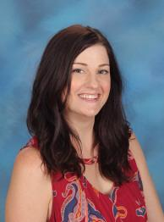
TEACHER SPOTLIGHT – Emily Lundberg
Emily Lundberg is our DRES newlywed! Congratulations to Mrs. Lundberg on her recent nuptials to Jake. Mrs. Lundberg is also one of our fantastic 3rd grader teachers and currently teaches on Track 3. In the past, she has taught 2nd grade and Computer Lab. Mrs. Lundberg is in her 10th year of teaching and is a graduate of Appalachian State University. Mrs. Lundberg is also mom to her two pups, Marcus and Molly.

In her spare time, Mrs. Lundberg loves to shop at Sephora and Ivy & Leo in Cameron Village! On a typical weekend you can find her relaxing at home or maybe seeing the latest scary movie at the Raleigh Grande. One thing you will notice about Mrs. Lundberg is that she has a deep love of all animals. She recently took a class on how to rehabilitate baby squirrels to set them back in the wild. She took care of four baby squirrels for several weeks until they were ready to be set free. Her favorite animals, however, are sharks! While she doesn't really like to go in the ocean at the beach, her dream is to swim with sharks one day.

VOLUNTEER SPOTLIGHT – Tracy Vander Meer
Ever since her eldest son began Kindergarten, Tracy Vander Meer has volunteered at DRES. For the past six years, Tracy has been and continues to be active member of the PTA, including several years as a voting member of the Board. Tracy enters her 5th year as the fall fundraiser coordinator running Boosterthon and now, Read-a-thon and is also the coordinator for the DRES art fundraisers and family reading nights.
Her favorite volunteer role, however, is as the leader of small reading or math groups two days each week. Tracy reminds us that “[y]our children are well-cared for at DRES…our teachers want to see ALL their students succeed!” When asked how parents can better partner with the school, she said, “Make sure your children are getting enough sleep!"

NO FUSS OPPORTUNITIES
August is the time to relink those grocery cards! Your Publix card doesn’t have to be relinked, but you will need to relink your Harris Teeter, Kroger and Lowe’s Foods cards. It’s simple. Beginning August 1:
- For Harris Teeter: Link your card at harristeeter.com (Together in Education) using DRES school code 1489 OR email dresptanofuss@gmail.com with your name and phone number or VIC card number and we’ll do it!
- For Kroger: Link your card at www.kroger.com (Community Rewards) using DRES school code 92664.
- For Lowe’s Foods: Link your card at lowesfoods.com (Cart to Class) using DRES school code 60113.

VOLUNTEERS NEEDED – Teacher Appreciation
By now, you have probably received the PTA flyer about teacher appreciation. The DRES PTA has several events planned for our hard-working teachers and staff, but we need your help. You can help the PTA with these events in lots of ways:

- Make a cash donation to allow the PTA to use for these events throughout the year – we recommend at least $5 per student, but any donation is welcome. Complete the flyer and attach your cash/check or send in a check with Teacher Appreciation in the memo line. Checks should be made payable to DRES PTA.
- Sign-Up to donate food items.
- Sign-Up to donate supplies.
- Volunteer at the teacher appreciation events – set-up, clean-up or help during the event.

If you have any questions about how you can help, please email dresptatreasurer@gmail.com.

