OCTOBER 2017 DURANT DISPATCH
DURANT ROAD ELEMENTARY SCHOOL

PTA PRESIDENT’S MESSAGE

UPCOMING DATES:

- October 20 – Teacher Appreciation event
- October 23 – PTA Meeting, 6:30 pm
- October 24 – Fall Picture re-takes (Track 4)
- November 2 – Spirit Night (City BBQ, 4 - __ pm)
- November 7 – Display My Art due
- November 20 – Book Fair set-up
- November 21 – Book Fair preview
- Nov. 27 – Dec. 8 – Book Fair

By Kyra Walgos
My sincerest thanks to everyone who participated in Read-A-Thon this year. Unfortunately, we did not reach our goal for the fundraiser, but the PTA is working to identify other fundraising opportunities that might ensure we can continue to fund all the student activities for the year.

On the horizon is the Reflections contest and Book Fair. Reflections is a wonderful opportunity for our DRES students to express themselves creatively within this year’s theme: “Within Reach”. I hope that each of you will encourage your child’s participation in this contest. Please refer to the Reflections flyer for more information! We can’t wait to see what the students create!

BOOK FAIR
The Book Fair is on its way! We’ll set up the day before Thanksgiving with a preview period for the teachers. The Book Fair will open for students on November 27 and run through December 8. This year’s book fair will be with Bedford Books.

Staff Spotlight – Jane Higgins
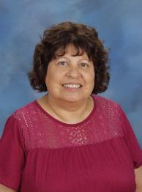
Jane Higgins has been a teacher in Wake County Public Schools for over 20 years and is currently part of the Intervention program at DRES. Ms. Higgins is proud of the educational system and has found North Carolina to be one of the most beautiful states she has lived in.

Ms. Higgins’ daughter, Amanda Higgins Roberts is also a teacher, in the Houston area. Did you know that close to 10,000 people are still living in shelters without a projected date of being able to leave because of Hurricane Harvey’s devastation? Many schools are still unusable and teachers have lost entire classrooms of materials.

To this end, Ms. Higgins has asked that we share information about “Adopt A Box”. The idea is to have a box in your place of business, church, school, recreation center or any place that people may gather. In this box, we collect school supplies, (please see the list below), gently used or new stuffed animals and paperback books for children.

Boxes can be delivered to you and picked up at your convenience. Please call and leave a voice message or text at 919-345-2020. Or you can contact me at froggladyhiggins@aol.com. For those who may not like to shop but would like to help with our cause you can go to the GOFUND ME. Adopt A Box School Supplies R-H. While it is the hope that shipping charges will be donated, there are alternative delivery methods, if necessary. Thank you for your consideration for the “Adopt A Box” project. This fund raiser will continue from now until November 12th.

ADOPT-A-BOX NEEDS
School supplies
Book bags
Pencils/erasers/pencil boxes or pouches /colored
Glue/glue sticks
Notebooks/spiral/composition
Scissors children and adult
Please do not include: hand sanitizer liquid white board cleaner clothes food
Tape/dispenser/masking
Staplers/staples
Strong magnets
Construction paper/tissue paper
Markers/dry erase markers/dry erase erasers
Ear buds
Crayons
Gift cards of all types

Any extra monies collected in the Adopt-A-Box School Supplies R-H GoFundMe will be used for the purchasing of supplies as listed above.

VOLUNTEER SPOTLIGHT – Gil Hicks
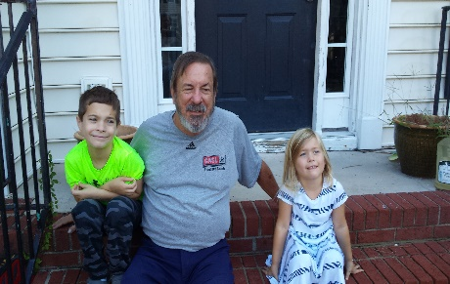
Gil has been a wonderful member of the DRES for the past two years. Gil has been married for 48 years to his wife Peggy and has been a Raleigh resident for 31 years. Together, Peggy and Gil have two children and seven grandkids. Gil is currently enjoying retirement from the electronics industry and volunteers at both DRES and Poe Elementary where 4 of his 7 grandkids attend. His DRES grandkids, Adam and Anna are in 3rd grade and Kindergarten on Track 2.

Gil is on the PTA and volunteers in the classroom at both schools, particularly reading with individual students, helping with Language Arts and Math and chaperoning field trips. This year at DRES, Gil is serving as the Member at Large and is leading the school’s Book Fair which begins November 27th.

When he’s not volunteering at the school, Gil has coached his grandsons in recreational soccer and was selected as the North Carolina Rec Coach of the Year by the NCYSA in 2016. Gil is avid reader, he likes to travel with his wife, and plays golf as often as possible.

Gil shares a wonderful insight about his involvement at DRES and Poe: “What gives me the most pleasure is seeing the face of a young child the moment he or she masters something and realizes they "got it." There is nothing nicer than the look on that child's face.”

NO FUSS OPPORTUNITIES – Tyson’s Project A+
NEW THIS YEAR! Our school is participating in the Tyson Project A+™ program, a fundraising program sponsored by Tyson Foods, Inc. Through this program, we can raise up to $12,000 for our school this year! The money can go towards supplies, building improvements, school programs, or anything else we choose. Here’s how it works: Just clip and collect Tyson Project A+ labels from participating Tyson® product packages and send them to school with your child. Each label is worth 24¢! There is a drawer for collecting the labels just inside the front door of the school across from the office. You can also find details online at ProjectAPlus.tyson.com. Please join us in collecting Tyson Project A+ labels this year and spread the word to your friends and relatives. It’s such an easy way to raise much needed funds for our school! Please email Shannon F. with any questions at dresptanofuss@gmail.com.

VOLUNTEER OPPORTUNITIES

- Teacher Appreciation: Teacher appreciation is coming on October 20, 2017 and the PTA could use your help. To sign-up for food or to volunteer, please visit: www.SignUpGenius.com/go/20F0E4DABAB2DA0FD0-teacher1
- Library: Our library and librarian need our support in ensuring books are on the shelves and ready for our students to read. There are almost 2,000 books in circulation each week that need to be re-shelved! Our primary goal is to have at least one parent volunteer for the library in the morning and one in the afternoon to assist with this task as well as helping the Junior Librarians. Even if you cannot volunteer for the 3-hour shifts, please feel free to sign-up even if you only have an hour or drop by any time you can. Contact Jennifer A. at jennifer.autry@gmail.com if you have questions! Sign-ups are available at: http://www.signupgenius.com/go/20f0e4dabab2da0fd0-media1

- Odyssey of the Mind: OOTM still needs coaches. “OOTM is an international creative problem-solving program that engages students in their learning by allowing their knowledge and ideas to come to life in an exciting, productive environment. Participants build self-confidence, develop life skills, create new friendships, and are able to recognize and explore their true potential. OOTM proves that students can have fun while they learn.” Coaches will provide supervision and handle logistics including scheduling meetings, completing paperwork, program teaching (using OOTM materials) and getting students to the competition. Commitment is once a week starting in October. We have a coach for Track 1 but need a second coach for combined Tracks 2-4. Please contact Lori Gibbons for details or to volunteer at lgibbons@wcpss.net.

NC State Fair - Wake County Schools Promotion
Support DRES by purchasing fair tickets in advance of the N.C. State Fair using DRES school code 398. For every adult ticket purchased using a school code, the State Fair will donate $2 to the school. For every child ticket purchased using a school code, the State Fair will donate $1 to the school. To support DRES, simply enter the school code (398) under "Membership" at check-out on the WCPSS Admission Ticket link. Use this link:
https://www.etix.com/ticket/p/7709276/wake-county-schools-offer-2017-ncstate-fair-gate-admission-good-any-one-day-raleigh-2017-north-carolina-state-fairadmissionridebooks-grandstand-events
This promotion is only available online in advance of the Fair. Tickets must be purchased by 11:59 p.m. on Thursday, Oct. 12.

MEMBERSHIP REMINDER:
Unfortunately, the PTA member numbers remain low. We hope that you will consider joining the DRES PTA. Joining PTA is a great way to work together to advocate for important issues in public education and support NCPTA’s advocacy efforts. Visit: https://drespta.memberhub.com for information!

SPONSORSHIPS
This year, the PTA is offering sponsorship opportunities to area businesses. Sponsorships start for as little as $250. If you know an area business that might be a good fit, please encourage them to reach out to the PTA president for more information. Or if you prefer, we can provide you a hard-copy of the sponsorship package. Email Kyra Walgos at dresptapresident@gmail.com.

THANKS TO OUR DRES SPONSORS!

Our Silver Sponsors:

Our Bronze Sponsors:

Our Platinum Sponsors:
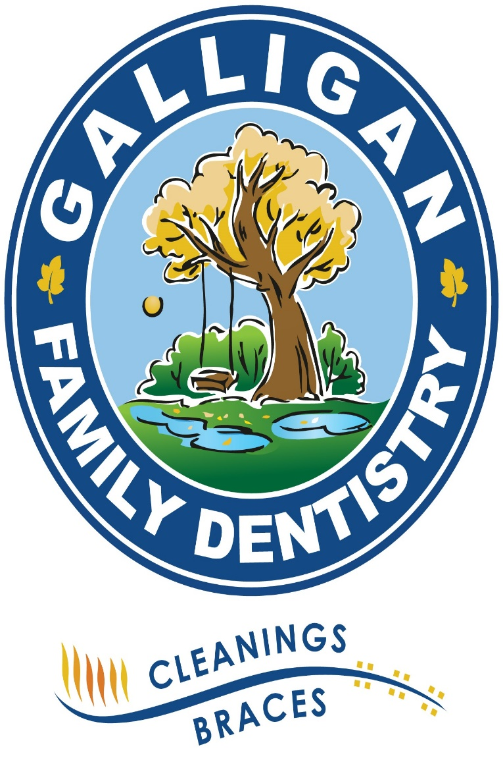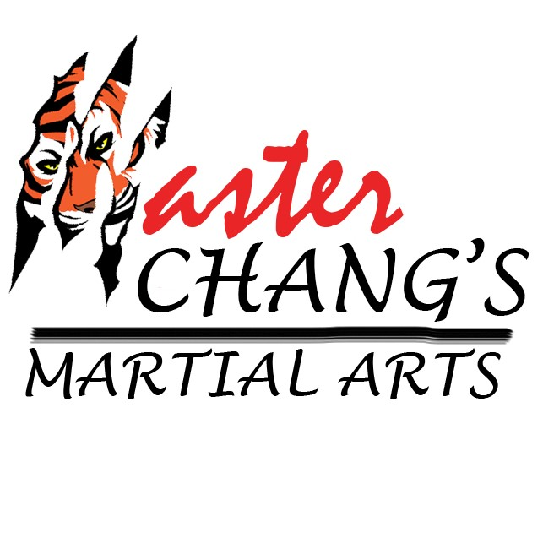

Our Gold Sponsors:
