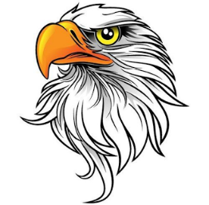

**SEPTEMBER 2017 DURANT DISPATCH**

**DURANT ROAD ELEMENTARY SCHOOL**

# PRINCIPAL’S MESSAGE

## UPCOMING DATES:

* August 28 – September 22 – PTA Read-a-Thon
* September 1: Spirit Wear Day
* September 5 – Fall Picture Re-Takes (Track 3-4)
* September 7 - Spirit Night at McDonalds, 4:30 pm – 7 pm
* September 8 – Spirit Wear Orders Due
* September 8 – RAT Dance Party (Tr. 1 & 4): K-2 (1:45 – 2:15), 3-5 (2:20 – 2:50)
* September 29 – RAT Dance Party (Tr. 2 & 3): K-2 (1:45 – 2:15), 3-5 (2:20 – 2:50)
* September 30 – NC Courage v. Orlando Pride, DRES Event, 7:30 pm, WakeMed Soccer Park
* October 3, 2017 – Fall Picture Re-Takes (Tracks 1-3)
* October 5, 2017 – Spirit Night at Chipotle
* October 6, 2017 – Display My Art order deadline

#### By Janet Kehoe

This year, the PTA’s major fall fundraiser will be Read-a-Thon, which I am excited about. In response to feedback from parents, teachers and staff, the PTA has decided to embark upon a new fundraiser which emphasizes literacy and reading. Most of the reading will be done during the student’s school day, but we always encourage parents to read with their students at every opportunity. I hope that this Read-a-Thon event will continue to encourage our young readers and make reading fun. I’m sure the reading prizes during the fundraiser will help too!

Also, we know how much the kids have loved running laps in the past fundraisers so this year, as a reward to the students for reading, we plan to host an energetic dance party to celebrate the end of the Read-a-Thon campaign and get them moving! We hope you can join us for the event! Please watch your Monday folders for more information about Read-a-Thon.

# PTA PRESIDENT’S MESSAGE

#### By Kyra Walgos

DRES Spirit Nights are a great way to support our school. These events are held approximately every month. August 8th marked our first spirit night of the year with a skating event at United Skates of America and resulted in about $300 to the school!

Our next event will be McTeacher’s Night on September 7th at the McDonald’s at Falls Pointe shopping center. Last year, this new spirit night proved wildly successful and we hope this event will be no different. What better way to support DRES than bringing your family by to enjoy dinner, meet DRES teachers and staff and interact with other DRES families. The kids LOVE this event because their teachers, administration and staff volunteer as servers, cashiers, drive-through window hosts and more. It’s one of the many reasons we love our DRES staff!

Last year the event raised more than $2,000 over the two events. McDonald’s gives DRES 25% of net sales during the event plus it provides hot fudge sundaes for $1 and spins from the prize wheel for $1 – all of those proceeds going directly to DRES. This year, we will have an opportunity to sign-up for the PTA during the event as well. I look forward to seeing everyone! Come hungry!

# READ-A-THON IS HERE!!

It’s time for STOP, DROP AND READ! Read-a-Thon is here! RAT will involve daily reading by your child in school and at the direction of your child’s teacher. Your role is helping to spread the message of RAT and helping your child connect with sponsors. The fundraiser is voluntary but the PTA hopes that everyone will participate as they are able. Our school-wide goal is to raise $35,000 to support replacing playground equipment on campus. This event accepts flat donations (no tracking per page!) and online payments are accepted with no convenience fee charged to the donor. Depending on your track, you may have already received sign-up information to get started. Any questions can be directed to dresptafundraising@gmail.com.

# REFLECTIONS CONTEST

The Reflections Contest theme for the 2017-2018 school year will be “Within Reach”. Every DRES student is encouraged to participate in this annual event. This contest welcomes students to create original works of art in dance, film production, literature, music, photography and visual arts. DRES will select a winner to represent the school at the county-wide level and advancing students may be considered for regional, state and national level awards and prizes. Last year, Eric Neugebauer, a 3rd grader in track 1, went to the Wake County level and won for a visual art work depicting his interpretation of “What is Your Story.” Additional information about this event will be coming soon.

# TEACHER SPOTLIGHT – Jennifer Welker

Welcome to Ms. Welker who is new to DRES and is teaching Kindergarten on Track 3. Although she is new at DRES, Ms. Welker is in her 15th year teaching. She is passionate about teaching children to read and has participated in many trainings in literacy and phonics to help her students. As part of this commitment, Ms. Welker recently participated in the Governor’s Teacher Network which focuses on action-based research for early literacy. Ms. Welker is a Raleigh native and graduated from UNCG with degrees in elementary education and psychology. Ms. Welker has two children that attend DRES, one dog named Molly and a cat, Callie. In her spare time, Ms. Welker loves to read, cook, be outdoors and spend time with her kids. We are so excited to have Ms. Welker as part of the DRES team.

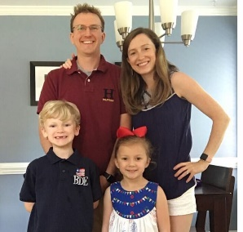VOLUNTEER SPOTLIGHT – Adam & Stephanie Elias

Stephanie and Adam Elias have been part of the DRES family since 2014, when their oldest son, Ben, started kindergarten. He is now in 3rd grade and their youngest, Kate, is in 1st grade.  Adam is an electrical engineer at a biotech company in RTP, and Stephanie is a stay-at-home-mom. The Eliases moved to Raleigh from Buffalo, NY 10 years ago, but aren’t going anywhere now! In the past, they have volunteered for DRES field trips and have become increasing more involved in DRES volunteer opportunities. Stephanie now works with others on the marquee board in the front of the school, Teacher Appreciation breakfasts and lunches, and in MakerSpace. Adam also helps with MakerSpace as well as spring carnival and STEAM night. Last year he designed, programmed, and built a robotic arm on his 3D printer to present to students during STEAM night. How awesome!

# NO FUSS OPPORTUNITIES

#### Spirit Nights

Spirit Nights are a quick and easy way to support DRES. We host these events on the 1st Thursday of the month, except January and June. Many of the events are a dinner drop in but could include other fun activities as well. A portion of the proceeds raised during the event goes directly back to the DRES PTA to fund activities at the school. As mentioned by our President, the next event is September 7th at the McDonald’s in Falls Pointe shopping center. We hope to see everyone there.

# VOLUNTEER OPPORTUNITIES

* Odyssey of the Mind: OOTM needs coaches. “OOTM is an international creative problem-solving program that engages students in their learning by allowing their knowledge and ideas to come to life in an exciting, productive environment. Participants build self-confidence, develop life skills, create new friendships, and are able to recognize and explore their true potential. OOTM proves that students can have fun while they learn.” Coaches will provide supervision and handle logistics including scheduling meetings, completing paperwork, program teaching (using OOTM materials) and getting students to the competition. Commitment is once a week starting in October. We have a coach for Track 1 but need a second coach for combined Tracks 2-4. Please contact Lori Gibbons for details or to volunteer at lgibbons@wcpss.net.
* Coffee Perks: This volunteer opportunity provides a quick and simple way to support the teachers and staff of DRES whether you are at the school regularly or can just drop by. The program runs throughout the year and we would love for you to sign-up for multiple weeks. All you have to do is sign-up for a week to bring ground coffee and creamers to the teacher’s lounge. It’s that simple! Sign up at: http://www.signupgenius.com/go/20f0e4dabab2da0fd0-coffee1
* Robotics Club: We are looking for 1-2 parents to work with Ms. Behr to coordinate the Robotics Club which will meet on either Tuesday or Thursday from 7-8 am. We already have a non-DRES parent that has volunteered to help set up the club and who has previously set it up at Brassfield ES. If you are interested, contact Theresa Dew at dresptastudentactivities@gmail.com.

# HOUSE BILL 13

In recent news and legislation, the passage of HB13 has resulted in changes to our classrooms and specials at DRES and more changes could be on the horizon. Read the bill at:

http://www.ncleg.net/Sessions/2017/Bills/House/PDF/H13v0.pdf.

# SPECIAL EVENT – WOMEN’S SOCCER GAME SUPPORTING DRES

On Saturday, September 30th come out and see the NC Courage take on the Orlando Pride at the WakeMed Soccer Park in Cary. Tickets are $10 and $1 from each ticket sale will be returned to the DRES PTA to support its activities. Watch PeachJar, Facebook and the flyer in Monday folders for more details about how to order tickets.

# THANKS TO OUR DRES SPONSORS!

Our Platinum Sponsors:

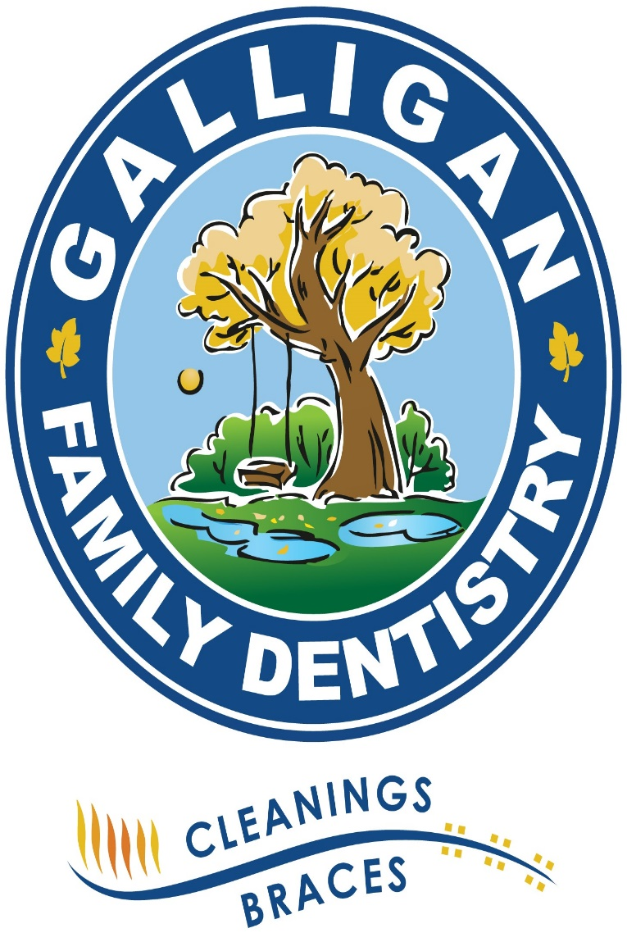 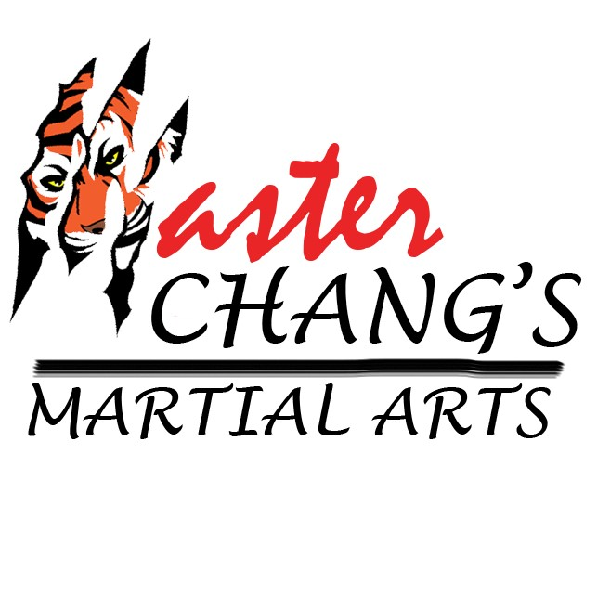

Our Gold Sponsors:

 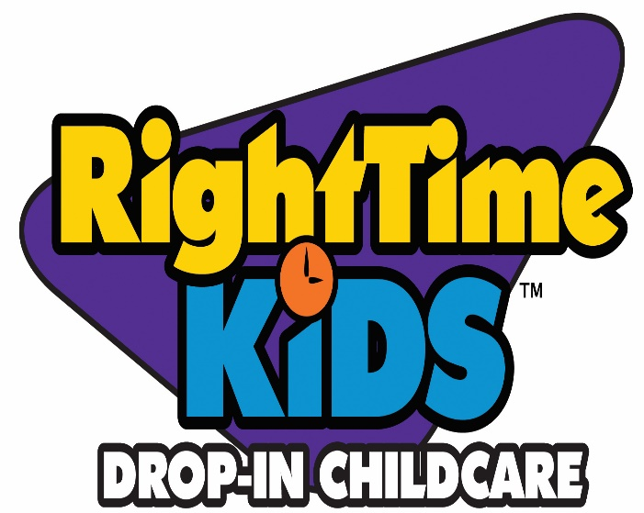

Our Silver Sponsors:



Our Bronze Sponsors:

  

# SPONSORSHIPS

This year, the PTA is offering sponsorship opportunities to area businesses. Sponsorships start for as little as $250. If you know an area business that might be a good fit, please encourage them to reach out to the PTA president for more information. Or if you prefer, we can provide you a hard-copy of the sponsorship package. Email Kyra Walgos at dresptapresident@gmail.com.